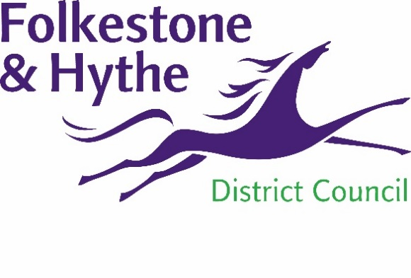
NEWS RELEASE

29 September 2021

COUNCIL TAKES NEXT STEP TOWARDS NEW HEALTH CENTRE

Plans for a new health centre with state-of-the-art facilities in the heart of Folkestone have moved a step closer.
Cabinet members have unanimously agreed to the proposed terms of a 150-year lease of the Victorian building at Folca on Sandgate Road in order that the project can be developed.
NHS Kent and Medway Clinical Commissioning Group has supported the principle of plans for a new surgery and will consider a business case once detailed plans have been developed.
These plans will set out what the new health centre will provide and then, subject to various permissions being obtained and consultation taking place, doors could open to patients in late 2024.
It is calculated that the delivery of the health centre would represent an estimated £16m investment into the town.
Cllr John Collier, F&HDC Cabinet Member for Property Management and Grounds Maintenance, said: “Ever since we purchased the former department store last year, it has always been our intention and key priority to deliver a new health centre and I’m pleased the scheme is progressing well.
“We have long recognised that Folkestone – just like all town centres – needs to adapt for the future and that the council has an important leadership role to play in this exciting new chapter.
“The redevelopment of Folca is an excellent example of us being proactive and working with partners to bring forward this project which will be a catalyst for transformation and stimulate future footfall into the town centre.”
The health centre forms part of the first phase of Folca’s redevelopment. Work around a potential mix of new housing, retail and commercial space in the Art Deco part of the site is still ongoing.
The Guildhall and Manor medical practices are proposing to come together to form the medical centre at Folca. As part of the proposed terms, Folkestone & Hythe District Council would retain the freehold of the site.
ENDS
Notes to Editors
For more information, please email communications@folkestone-hythe.gov.uk

Follow us on Facebook: @FolkestoneandHytheDC
Follow us on Twitter: @fstonehythedc
Follow us on Instagram: @folkestonehythedc
Follow us on LinkedIn: Folkestone & Hythe District Council

